DARIA MELNIKOVA

Pasimatymas / Date Night

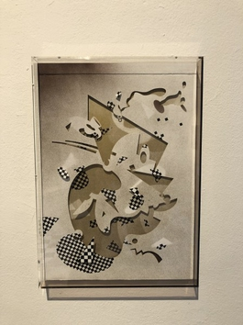 | Daria Melnikova  Meet Mr. Jazzy Sunday (balance roaster), 2020  Organinis stiklas, lazeriu išpjaustytas popierius, tušas, purškiami dažai / Plexi glass, lasercut paper, ink, spray paint  42,5 x 30 x 4 cm  (MEDA-013) | € 1,100.00
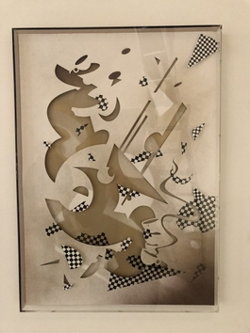 | Daria Melnikova  Stress grinder, 2020  Organinis stiklas, lazeriu pjaustytas popierius, tušas, purškiami dažai / Plexi glass, lasercut paper, ink, spray paint  60 x 42,5 x 4 cm  (MEDA-012) | € 1,400.00
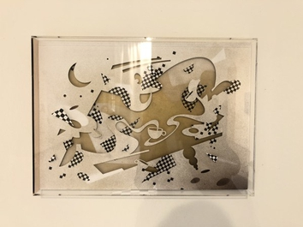 | Daria Melnikova  Meet Mr. Jazzy Sunday (cup juggler), 2020  Organinis stiklas, lazeriu pjaustytas popierius, tušas, purškiami dažai / Plexi glass, lasercut paper, ink, spray paint  30 x 42,5 x 4 cm  (MEDA-011) | € 1,100.00
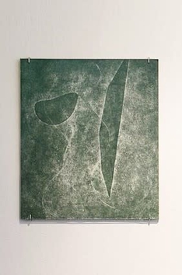 | Daria Melnikova  Tomorrow. , 2014  Spauda ant popieriaus / cardboard print on paper  35 x 45 cm  (MEDA-010) | € 600.00
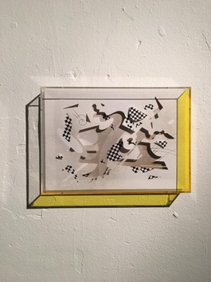 | Daria Melnikova  Meet Mr. Jazzy Sunday! , 2018  Organinis stiklas, lazeriu pjaustytas popierius, tušas, purškiami dažai / Plexi glass, lasercut paper, ink, spray paint  21,5 x 30 x 4 cm  (MEDA-009) | € 800.00
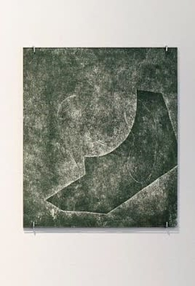 | Daria Melnikova  Tomorrow Again, 2014  Spauda ant popieriaus / cardboard print on paper  35 x 45 cm  (MEDA-008) | € 600.00
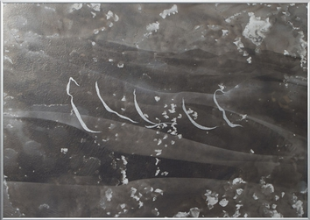 | Daria Melnikova  Signs I, 2014  Pelenai, cinko-aliuminio dažai, aliuminis rėmas / Ashes, aluminum-zinc paint, aluminum frame  42 x 60 cm  (MEDA-007) | € 2,500.00
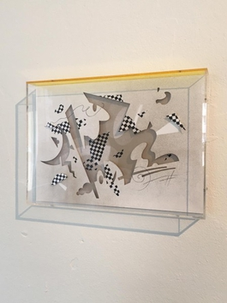 | Daria Melnikova  Meet Mr. Jazzy Sunday!, 2018  Organinis stiklas, lazeriu pjaustytas popierius, tušas, purškiami dažai / Plexi glass, lasercut paper, ink, spray paint  21,5 x 30 x 4 cm  (MEDA-006) | € 800.00
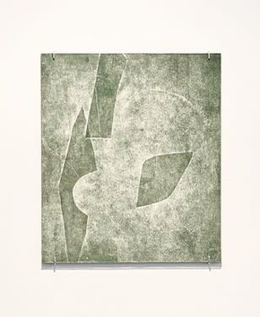 | Daria Melnikova  The Day After. , 2014  Spauda ant popieriaus / cardboard print on paper  35 x 45 cm  (MEDA-005) | € 600.00
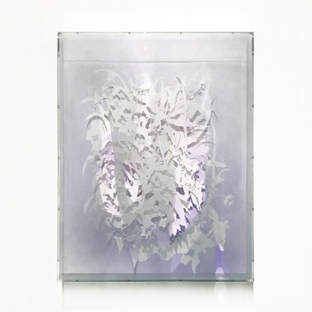 | Daria Melnikova  Bearing Petals / paper version, 2017  Lazeriu išpjaustytas popierius, organinis stiklas, purškiami dažai / Lasercut paper, plexiglass, spray paint  56 x 76 x 6 cm  (MEDA-004) | € 2,500.00
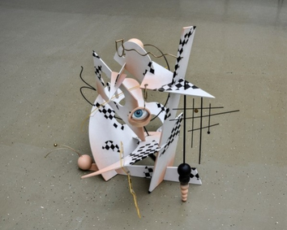 | Daria Melnikova  Meet Mr. Jazzy Sunday, 2018  Dažyats medis, metalas, organinis stiklas, dažyats poliuretanas / painted wood, metal, plexi glass, painted polyurethane  Dydis kintantis / Dimensions variable  (MEDA-002) | € 3,200.00
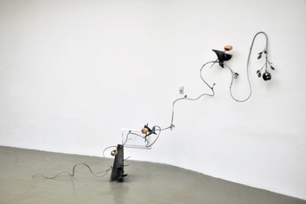 | Daria Melnikova  Date Night, 2018  Metalinis strypas, nerūdijantis plienas, dažyta mediena, pagal užsakymą pagamintos dažytos poliuretano formos / Metal rod, stainless steel, painted wood, custom made painted polyurethane shapes  Dydis kintantis / Dimensions variable  (MEDA-001) | € 4,600.00

